Part 1:
#!/bin/bash
echo "Retrieving info to create new user."

read -p "Please enter a login name: " login_name
read -p "Please enter the full name (GECOS): " full_name
read -p "Please enter the login shell (e.g., /bin/bash): " login_shell
read -p "Please enter the home directory (e.g., /home/username): " home_directory

echo "Creating user..."
sudo adduser --home "$home_directory" --shell "$login_shell" --gecos "$full_name" "$login_name"

echo "User $login_name has been created successfully."

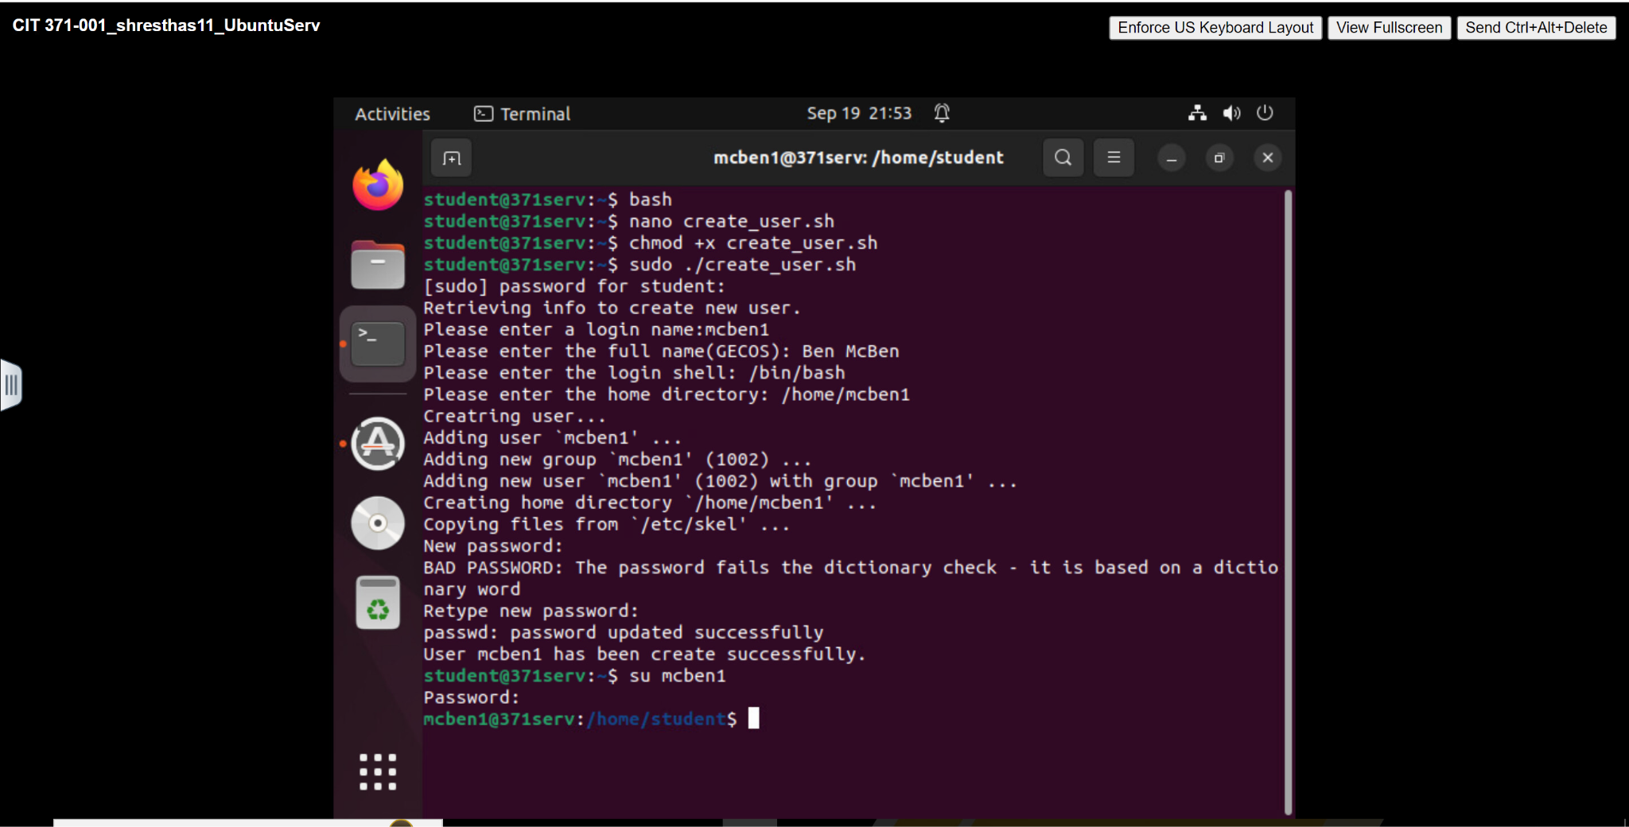

Part 2:
#!/bin/bash

echo "Files:"
for item in *; do
if [ -f "$item" ]; then
echo -e "\t$item"
fi
done

echo "Directories:"
for item in *; do
if [ -d "$item" ]; then
echo -e "\t$item"
fi
done

